Table of Contents
1. Introduction 2
2. Performance Of Next, Jd Sports Fashion & H&M 3
2.1 Hypothesis Testing Using ANOVA 7
3. Impact of Currencies Exchange Rate Movements On Company Performance 9
4. New Business Proposal 12
4.1 Project Details 13
4.2 Monte Carlo Simulation 14
5. Conclusion and Recommendations 15
5.1 Recommendations for Investors 16
5.2 Limitations of the Analysis 17
6. Appendices 18
7. References 20

1. Introduction

This report examines financial performance within the UK fashion retail sector by analysing three companies operating under the Retail Trade classification (UK SIC 47). According to the British Consortium report (2025), the retail sector consists of around 3 million workers and contributes approximately 5% in the Gross Domestic Product (GDP) of the country. The landscape of the UK retail sector, especially fashion retail, changed over the last few decades due to digital transformation, expansion of e-commerce, supply chain globalization and inflationary pressures. Brydges et al. (2020) highlighted that the international outbreak of COVID-19 created an emerging need of urgency for many economic activities and proved to be a turning point for many industries particularly fashion and textile. The pandemic caused significant challenges, including supply chain disruptions, operational uncertainty, alongside major shifts in consumer behaviour. This collectively accelerated demands for more sustainable business practice and transparency across the industry (Black, 2020). These factors created different performance outcomes across major retailers, making the sector suitable for comparative financial analysis.
The main objective of this study is to apply quantitative techniques to assess the overall performance, identify different statistical patterns across companies, and explore how external factors, such as currency movements shape the financial performance outcomes. The data used for analysis in this report is obtained from FAME, Yahoo Finance, and companies annual reports to ensure the availability of consistent and comparable data over a minimum ten-year period. The selected firms - Next PLC, JD Sports Fashion PLC and H&M HENNES & MAURITZ Group UK were chosen based on data availability, relevance and comparative performance suitability.
All three companies operate predominantly in fashion and apparels, ensuring same industry alignment for comparability. They are publicly listed, providing access to over 10 years of financial data for statistical and trend analysis. Furthermore, these companies have been widely studied in academic literature covering various topics ranging from supply chain efficiency, sustainability, consumer behaviour and digital transformation, facilitating strong theoretical framework for interpretation of the observed performance trends.
The report is organised into three major sections, each addressing a core area of financial analysis within the fashion retail sector. The first section evaluates profitability and capital efficiency using Gross Profit Margin and Return on Capital Employed ratios, supported by descriptive statistics, graphical analysis, and inferential techniques such as ANOVA to determine whether performance differences across the three selected companies are statistically significant. The second section examines the behaviour of major global currencies and considers how exchange rate movements influence retailers that depend heavily on international sourcing, logistics, and other global operations.
The final section employs simulation-based techniques to forecast investment risk and estimate key financial metrics relevant for assessing the profitability of new entry into the sector. The report concludes by summarising the key findings, outlining the recommendations for investors, and acknowledging the limitations associated with the data and methodology used.

2. Performance of Next, JD Sports Fashion & H&M

Gross Profit Margin (GPM) and Return on Capital Employed (ROCE) were selected as key indicators to evaluate financial performance within the fashion retail sector due to their relevance in assessing both profitability and long-term efficiency. The Gross Profit Margin reflects a company’s ability to manage production costs and pricing strategies effectively, providing insight into profitability and market competitiveness (Patel, 2021).

In the retail context, maintaining a stable or improving gross margin is often associated with effective cost control and brand value creation. Return on Capital Employed, on the other hand, measures how efficiently a company utilises its deployed total capital to generate operating profits. In other words, it is a key indicator of how efficiently a firm delivers value by utilizing its capital (Rosario, 2024). ROCE is widely used in academic and industry research as a measure of value creation, operational efficiency, and strategic profitability. According to Ogah et al. (2024) a higher ROCE typically indicates strong capital utilisation and robust operating performance, while lower ROCE may reflect inefficiencies in asset management or weaker operational returns.
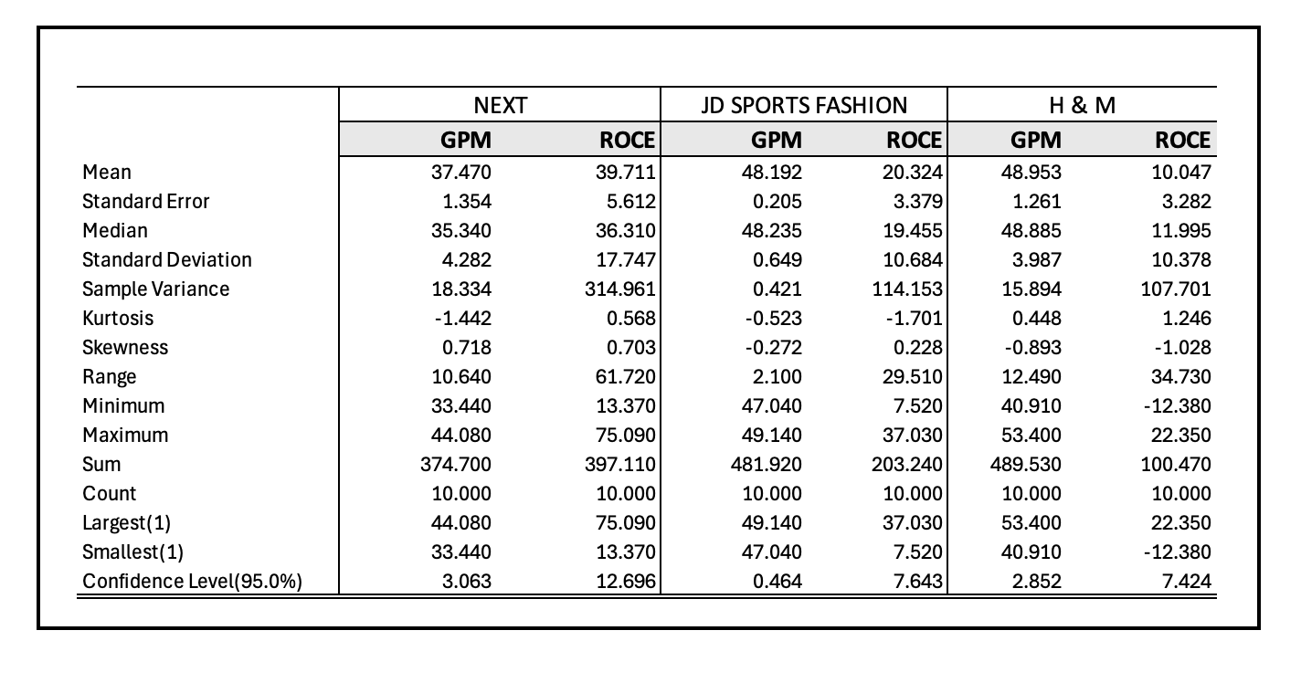
To conduct descriptive statistical analysis, ten years of financial data for the three companies were extracted from FAME and organized in Table 1 in Appendix. Descriptive statistics were then calculated for the relevant financial ratios, with the results summarized in Table 1.1 below
Table 1.1: Descriptive Statistics of NEXT, JD Sports and H & M

To further demonstrate the financial performance of the three companies, visual representations of key financial ratios, Gross Profit Margin (GPM) and Return on Capital Employed (ROCE) are presented in Figures 1(a) and 1(b). These figures, derived from the data in Tables 1(a) and 1(b) in the Appendix, complement the descriptive statistics reported in Table 1.1 and provide a clear comparative perspective on the companies’ profitability and capital efficiency trends.

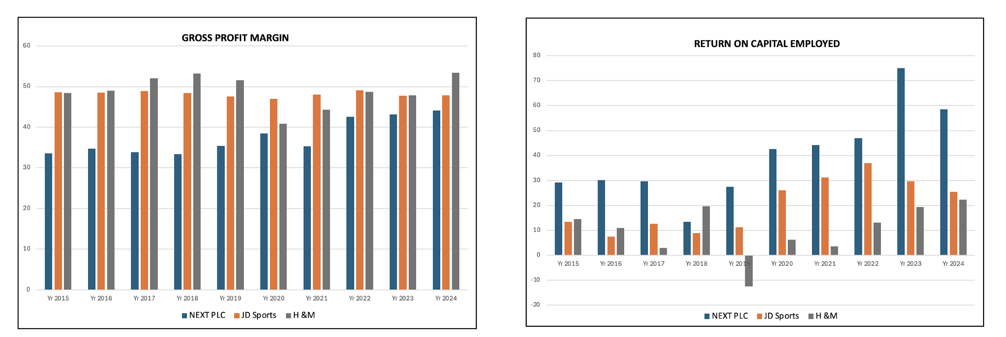
Figure 1(a): Illustration of GPM of NEXT, JD Sports and H &M
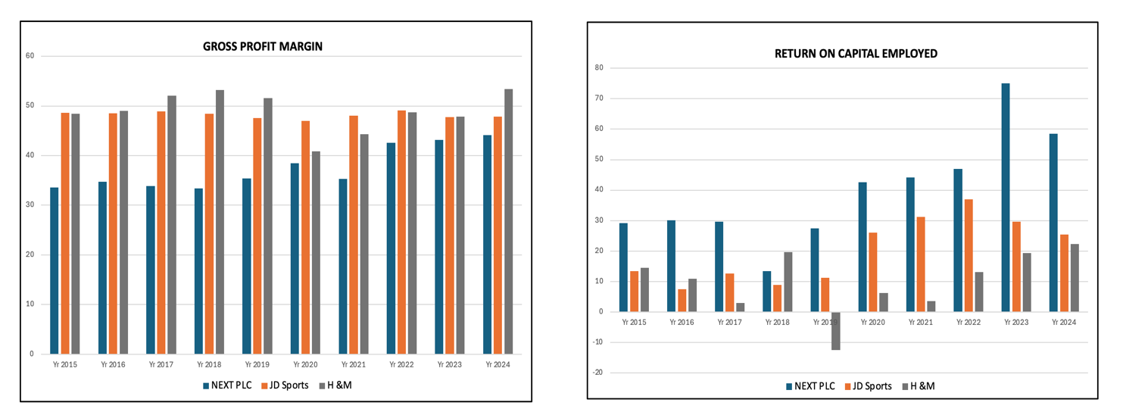

Figure 1(b): Illustration of ROCE of NEXT, JD Sports and H &M

H&M exhibits the consistent highest Gross Profit Margin (GPM) trend, a position primarily driven by its massive global scale which facilitates superior economies of scale and low procurement costs per unit across its vast supply chain (H & M Hennes & Mauritz AB, 2024). H & M marked its lowest GPM ratio in 2020; this was mainly due to the dropped in sales and disrupted supply chains during COVID-19. According to the Worker Right Consortium (2020), the pandemic triggered a substantial drop in global demand for apparel, placing considerable pressure on fashion retailers. Despite these challenges, H&M along with several other major brands committed to paying in full for orders that were completed or already in production, helping to stabilise supplier relationships during a period of uncertainty. This commitment, combined with subsequent operational improvements, supported the company’s recovery in the years that followed. Moreover, a recent successful operational benefit that reduced markdowns, allows its GPM to be structurally high despite operating in the highly competitive fast-fashion, volume-driven segment.

However, H&M consistently posts the lowest Return on Capital Employed (ROCE), reflecting the heavy burden of its high working capital and capital-intensive legacy store network, due to its large asset base generating a comparatively modest return on investment (H & M, 2023). The company’s ROCE reached its lowest point in 2019, falling into negative territory. This decline reflects the severe operational pressures unfolding during the early pandemic period, when retailers faced surging logistics and fulfilment costs, sharp reductions in stores, and mounting levels of unsold inventory. The need to engage in massive discounting to clear stock further eroded operating profitability, ultimately pushing returns on capital employed below zero and signalling a period of significant value destruction and strategic vulnerability for the business. In the years that followed, the company began to show a gradual recovery in its ROCE performance, indicating a slow but measurable improvement in operational efficiency and profitability as market conditions stabilised and strategic adjustments started to take effect.

JD Sports consistently ranks second in Gross Profit Margin and occupies a mid-position in Return on Capital Employed, reflecting a high-growth strategy supported by substantial ongoing investment. Its strong Gross Profit Margin is mainly due to the company's premium positioning within the sportswear market. According to (JD Sports Fashion PLC, 2024) exclusive product collaborations, brand partnerships, and aspirational pricing provide JD Sports with considerable pricing power and higher-than-average mark-ups. In contrast, its moderate ROCE, generally ranging from 15% to 20%, reflects the capital-intensive nature of its expansion strategy. As highlighted in the annual report, continuous investment in new stores, international market entry, and inventory growth temporarily places downward pressure on capital efficiency, resulting in a lower ROCE relative to its gross margin strength (JD Sports Fashion PLC, 2025). Overall, the company’s financial profile illustrates the trade-off between rapid expansion and short-term efficiency metrics within the fashion retail sector.

NEXT PLC shows the lowest GPM among its peers while simultaneously achieving the highest return on capital employed (ROCE), frequently exceeding 30%. Its stable GPM (around 43-45%) is protected by its highly disciplined multi-channel business model and sophisticated, low-markdown inventory management (NEXT PLC, 2023). Most importantly, its ROCE dominance is due to its capital-light "Total Platform" strategy, which leverages existing logistics and technology infrastructure to service third-party brands. This approach facilitates the generation of high levels of operating profit without a proportional increase in capital employed, thereby establishing NEXT as the most capital-efficient operator within its peer group. These findings align with prior research on capital efficiency, multi-channel retailing, and platform-based business models (Mantin, 2014).

2.1 Hypothesis Testing Using ANOVA
To evaluate whether the overall performance of the three companies differs in a statistically meaningful way, Gross Profit Margin (GPM) was selected as the key performance indicator, and an inferential analysis using one-way ANOVA was conducted. ANOVA is a statistical technique used to compare mean values across three or more independent groups by examining both between-group and within-group variance, thereby determining whether observed differences exceed those expected by random variation alone (Ostertagova & Ostertag, 2013). In its simplest form, one-way ANOVA tests whether statistically significant differences exist in the mean values of a single dependent variable across multiple independent groups (Koetter et al., 2014).
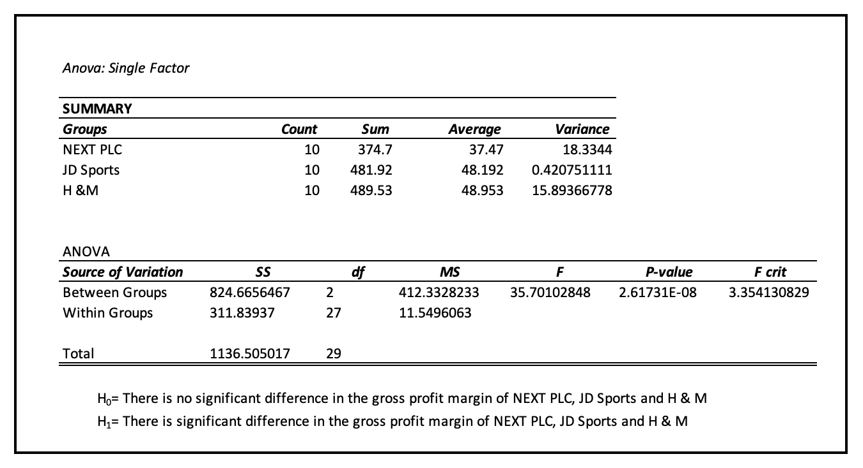
For this study, the following hypotheses were specified: the null hypothesis (H₀) proposes that no significant difference exists in the gross profit margins of the three companies, whereas the alternative hypothesis (H₁) asserts that the GPMs of NEXT, JD Sports, and H&M differ significantly. The analysis was performed using a 95% confidence level. The resulting ANOVA output is presented in Table 1.2, derived from the input data provided in Table 1(a) of the Appendix, providing the basis for determining whether the variation in profitability among the firms is statistically significant.
Table 2: ANOVA Single Factor Analysis
The Single factor ANOVA conducted at the 95% confidence level produced a p-value of 2.62 × 10⁻⁸, which is far below the significance threshold of 0.05. This extremely small p-value indicates that the observed variation in Gross Profit Margin (GPM) among NEXT, JD Sports, and H&M is not attributable to random chance. Consequently, the null hypothesis (H₀), which stated that there is no significant difference in GPM across the three companies, is rejected.
This result provides strong statistical evidence that the three firms differ significantly in their gross profitability performance over the period analysed. In practical terms, the companies do not share comparable GPM levels; rather, their profitability structures are distinct. Although the ANOVA result confirms a statistically significant difference in GPM across the three companies, post-hoc pairwise tests were not conducted, as the objective of this study was to evaluate overall performance differences rather than identify specific pairwise contrasts.

3. Impact of Currencies Exchange Rate Movements on Company Performance
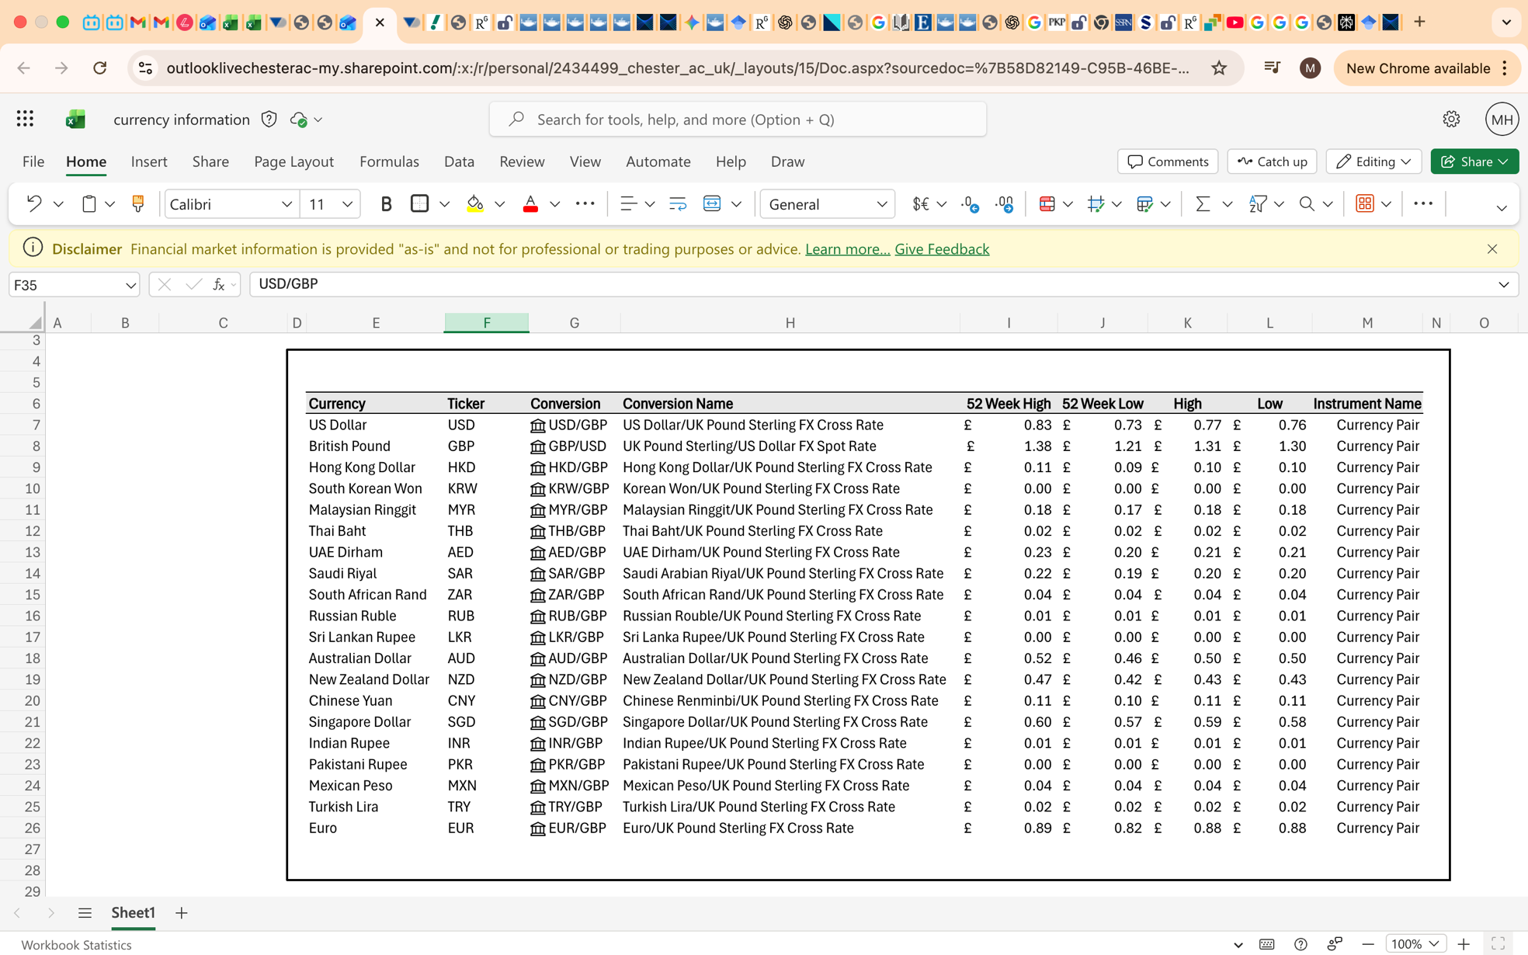
Exchange rate dynamics, particularly involving the GBP/USD currency pair, play a central role in shaping the financial performance of multinational retailers whose operations span procurement, production, and sales across global markets. Corpay (2024), emphasizes that multinational corporations face significant impact on their financial performance due to volatility in exchange rates, particularly when operating across currencies. Moreover, Taylor (2021) states that the Foreign Exchange risk leads to real, negative consequences for business growth and investment plans. For big companies such as H&M, NEXT Plc, and JD Sports Fashion, the reliance on international sourcing and cross-border transactions fluctuations in sterling relative to the US dollar directly influence cost structures, supply chains and profitability. Given the prominence of USD-denominated purchasing in global apparel supply chains, movements in GBP/USD can exert material impacts on operational performance. The dashboard to examine the currency behaviour against GBP/USD currency is illustrated in Table 3
Table 3: Dashboard displaying twenty major Currencies
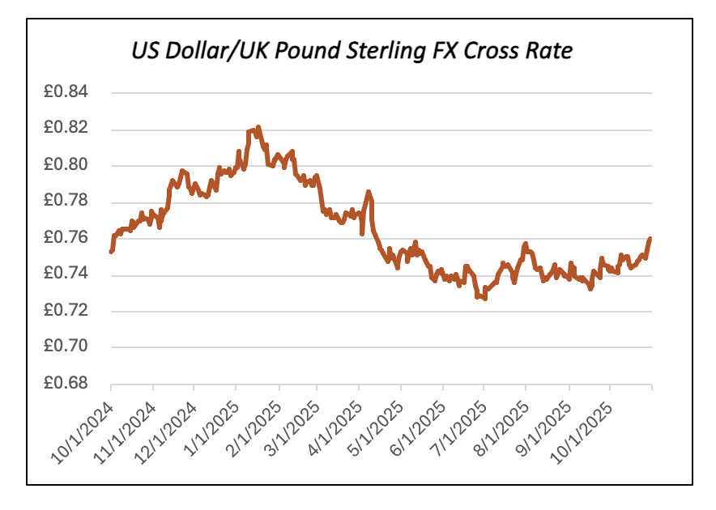
The dashboard incorporates 20 major currencies, each converted into the base currency (GBP), together with other market indicators such as high, low, 52 week high and low values. For analytical illustration of impact on currency on performance of the three selected companies GBP/USD is used as the main currency pair, drawing on one year of historical data. A data validation dropdown menu is designed to facilitate the selection of any currency within the dashboard as displayed in Table 2.1 in Appendix. This interactive feature enhances the usability by allowing users to examine individual currency movements relative to GBP. To demonstrate the broader movement in currency performance, Figure 2 illustrates the overall currency fluctuation of the USD/GBP exchange rate over the past year.

Figure 2: Trend of GBP/USD currency pair fluctuation over one year

Annual reporting by H&M (2025), shows that around half of its total sales are received in Euros, while its most widely traded currencies are US Dollar and Euro. Notably, H&M highlights exchange rate fluctuations between USD as its most substantial foreign currency exposure mainly because USD is widely practiced as the major sourcing currency for raw materials and finished products. Any rapid or drastic changes to the values of USD may have substantial indirect impacts on purchase prices even though H&M clarifies that such changes remain largely competition-unadjusted for extensive periods because most companies share similar levels of foreign currency exposure. To cover these foreign currency risks associated with its activities, H&M makes extensive use of foreign currency flow hedges combined with significant reliance on forward foreign currency contracts to fix exchange rates for future payment flows linked to goods sourcing activities. As for additional foreign currency exposure risks beyond its foreign currency transaction exposure risks, H&M also faces translation risks linked to its foreign subsidiary earnings consolidated in Swedish Krona (SEK).
The case of H&M is representative of various academic discussions on the importance of exchange rate risks to multinational enterprises' operations. Notably, Pellegrino (2024) highlighted that foreign-exchange risk can significantly inflate procurement costs, and cross-border operations. Likewise, (Li et al.,2024) further reveals that in volatile Foreign Exchange environments firms often shift toward more flexible logistics modes to manage the financial risk associated with currency fluctuations. This is because retail apparel companies have been noted to work within environments of high lead time for production processes linked to internationally diverse sourcing and price-demand volatility of products offered to consumers.
UK-based companies like Next PLC and JD Sports Fashion take notice of the GBP/USD correlation. Many UK clothing and footwear retailers source their products from markets priced in USD and located in Asia; thus, any devaluation of the pound against the USD impacts positively on import prices or margins and pushes towards high prices. Such past events of devaluations of sterling because of Brexit trade agreement (2020) and other political uncertainties indicate just how quickly higher sourcing prices can negatively impact UK retailers' profits. Big retailers like JD Sports may have better opportunities to shift higher prices to their customers, while mid-market players like Next PLC must use cost management measures or negotiate new terms or improve their hedging policies to cope with tough sourcing prices.
The existence of vulnerabilities to currency-related risks is universally acknowledged and countered by the strategic approach to currency risk management through currency hedging or stabilisation using stable contract currencies like USD or EUR (Levi, 2022). Similarly, Badhan et al. (2024) suggests that one of the most effective strategies to eliminate distortions associated with currencies is to adopt hedging or use contract currencies that are not subject to same market volatilities associated with fast-moving industries like the fashion retail industry because of low margins. This strategic planning addresses vulnerabilities by acting as a shelter or additional safety net for organizations against foreign currency fluctuations or volatilities because empirical analysis clearly shows that companies which actively hedge against foreign currency risks have higher cost stability on their supply chains than others do (Levi, 2022).
In such a case, H&M's hedging system gives it an edge over its market rivals because others may not have adopted such measures or may have adopted them reactively or to a limited extent. UK retailers such as Next Retail and JD Sports also employ hedging techniques and instruments, but their success is subject to factors such as hedge timing, ratio of hedge to total risk exposure, and overall duration of market vulnerabilities to exchange fluctuations. A weakening GBP against USD affects companies that do not have market hedging to their full extent because of higher cost pressures leading to adjustment or further cost reduction through margin management.
Overall, the performance of the GBP/USD exchange rate affects H&M group, Next PLC, and JD Sports Fashion significantly because of its wide array of impacts on these organizations directly and indirectly through translation processes. The empirical literature supports business practice and confirms the importance of proactive and organized management of currency risks such as hedging or use of currency-stable agreements to mitigate performance risks associated with highly integrated retail industries across various geographical settings around the world.

4. New Business Proposal
The fashion retail sector offers several strategic opportunities for new entrants, particularly due to ongoing structural shifts in consumer behaviour, digitalisation, and sustainable fashion trends. McKinney & Company (2024) report highlighted that there is strong growth in omni-channel retailing and accelerated e-commerce activities, which reduced the entry barriers and facilitated new firms to reach customers without heavy dependence on physical locations. Many studies also resonated with the view that niche and digital transformation helped the retailers in gaining large market share as consumers increasingly value convenience, personalisation, and ethical production (Brydges & Hanlon, 2020). These developments depict that opportunities exist for new fashion retailers who combine differentiated product offerings with operational efficiency and strong digital capability.

4.1 Project Details
Starting a new fashion retail business requires substantial capital, particularly for inventory, logistics systems, branding, and store fit-out. Industry estimates indicate that a typical UK fashion start-up requires between £200,000 and £700,000 depending on the scale of launch, quality of inventory, and location (IBISWorld, 2025).
Based on these benchmarks, this report adopts a model project with a 10-year life span and initial investment of £500,000. This allocation covers key expenditure categories including store refurbishment, first-season inventory, supply-chain set-up, technology infrastructure, marketing, and early operational costs.
Projected annual operating cash flows of £190,000 are consistent with revenue patterns of early-stage retailers operating on a physical location supported by online sales. However, such projections must be interpreted cautiously as fashion retail is known for substantial cash-flow volatility due to seasonality, fashion sensitivity, and markdown risk (Bhardwaj, 2010). Retail Economics (2023) reported heightened cash-flow volatility reports during the latest trading season, attributed to consumer restraint, changing fashion trends and economic uncertainty. Consequently, investment evaluation in this sector must account for the inherent volatility of demand and margins, as failure to recognise these risks can lead to unrealistic profit figures leading to poor capital-allocation decisions.
Furthermore, Industry research highlights that rising input costs, supply-chain disruptions, and fluctuating consumer demand create unpredictable year-to-year performance (McKinsey & Company, 2024). To reflect this uncertainty, a 60% standard deviation is applied to cash-flow projections due to consistent volatility ranges identified in small retail firms exposed to demand shocks and inventory risk. Financial modelling resources recommended stress testing for cash-flow projections in small firms, where volatility can reach or exceed 50–60% in extremely uncertain market conditions, specifically in fashion and seasonal retail. A discount rate of 9% (WACC) is used, aligning with the sector specific literature suggesting that the moderate level retailer pushes discount rates into the 7-9% range. This figure is also supported by KPMG’s (2023) Cost of Capital study report, which highlighted that the WACC for the sub-sector of retail increased from 7.0% to 8.1% due to higher interest rates and risk premiums dependent on macroeconomic conditions.

4.2 Monte Carlo Simulation
A Monte Carlo simulation-based investment appraisal was conducted in creating the dashboard, incorporating cash-flow volatility into the project valuation. Monte Carlo Simulation is a computational technique which uses repeated random sampling to obtain the likelihood of a range of results, especially in assessing risk and financial modelling (IBM, n.d). It is a widely recognized method for investment decision-making particularly for new businesses operating in uncertain environments. This approach facilitates the decision-makers in assessing the risk and financial results associated with the investment project by assessing the net present value of investment in terms of other variables such as interest rate, production volume and market constraints (Lumnitzer et al., 2024). The dashboard for our project is demonstrated in Figure 3
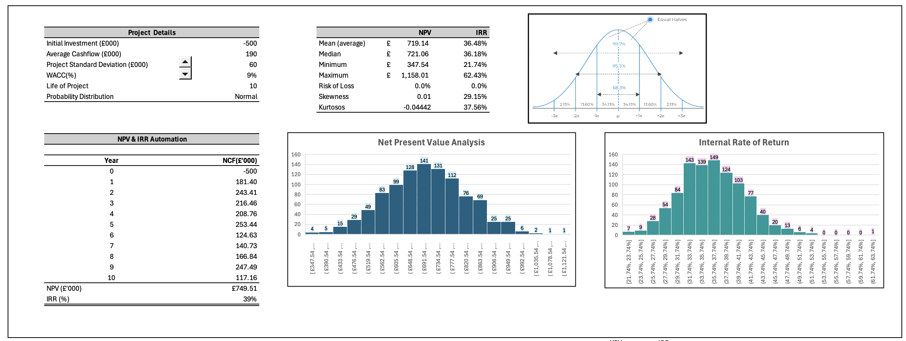
Figure 3: Dashboard illustrating Monte Carlo Simulation for a new Business Project

The dashboard presents the results of an Excel-based Monte Carlo investment appraisal in which 1,000 trials were used to transform a business model into a probabilistic valuation of a ten-year retail project. For each trial the spreadsheet computes project NPV and IRR, producing empirical distributions for both metrics. The mean NPV is £719.14, indicating that, on average, the project is expected to create value. Since this average value is positive, the investment appears financially viable. The median NPV is £721.06, which is very close to the mean, suggesting a largely symmetrical distribution with minimal influence from extreme outliers.
The positive NPV value of £719.140 demonstrates that, after discounting future cashflows for the time value of money and the risk, the project is expected to generate higher value than its cost. Likewise, the estimated IRR of 36.49%, which is significantly higher than the WACC value, implying a sizable return on capital. This differential provides a strong financial buffer, reinforcing the project’s attractiveness and suggesting that it would generate value even under less favourable conditions.

5. Conclusion and Recommendations
Overall, the comparison analysis performed on NEXT PLC, JD Sports Fashion PLC, and H&M shows that each of these companies differs widely in terms of its respective profitability and capital efficiency ratio. H&M reported consistently high Gross Profit Margins because of its economies of scale and effective sourcing strategies all around the world but yielded the lowest ROCE because of its substantial capital base and operational difficulties because of its large number of retail stores, characteristics often associated with bricks and mortar scale (Mullner, 2017). Similarly, JD Sports PLC reported high GPM because of its strong brands and exclusive products but yielded moderate returns because of its expansion policies. NEXT PLC reported low GPM but reported high ROCE because of its effective use of technology and efficient business operations. The analysis also showed significant differences between GPM reported by each of these companies through the ANOVA test and supports the assertion that each company follows its own strategic and operational path.
The analysis of exchange rate behaviour makes it clear that GBP/USD volatility pressures all three retailers to some extent because of their reliance on USD-indexed sourcing. This directly impacts cost, margin, and pricing policies that each company adopts to hedge against such fluctuations or protect themselves against exchange rate volatility. H&M's strategy shows clearly how it hedges foreign exchange risks to stabilize sourcing prices, while UK-based retailers like NEXT and JD Sports continue to remain vulnerable to GBP depreciation, further underlining import prices and thus profitability. It is apparent from dashboard analysis that fluctuations of currencies during this analysis period have remained volatile and thus continue to make this sector's operational performance vulnerable to exchange rate fluctuations.
The investment analysis for the new retail venture demonstrates that it is financially viable under the assumed scenarios. Using the initial investment of £500,000 and annual cash flows of £190,000, the result of the simulation analysis demonstrates that it is financially viable since its NPV is positively expected and its IRR is significantly higher than the discount rate. The analysis also takes into consideration the high volatility associated with the fashion retail market and shows that even under uncertainty, its business model is still capable of generating value. This analysis is reflective of contemporary retail markets, which because of niche retail specialization, digital oriented and efficient supply chain management, remain conducive to new retail ventures.

5.1 Recommendations for Investors
- Based on this analysis, for risk averse investors seeking stability and high capital efficiency, NEXT appears to be a better investment option for the future because of its steadiness in terms of ROCE values and sound business acumen.
- For growth-oriented investors, JD Sports is an option because of its robust partnerships and growing geographical reach, ensuring their margins remain resilient despite efficiency ratios being moderate. H&M provides excellent gross margins but may need to be viewed cautiously because of its low efficiency ratio and significant operational commitments for large-scale business activities.
- For the new start-up investment proposal, analysis suggests moving forward with the project if it sustains itself with low operational costs and employs effective inventory management processes and dynamic currency risk management strategies.
- It is also crucial to maintain sufficient liquid reserves because of high volatility associated with cash flows, especially for companies operating within the fashion retail industry.

5.2 Limitations of the Analysis
It is important to note that there are several limitations of this analysis. Firstly, being based on historic figures, the financial ratios may not depict entirely new strategic developments or market changes on the retail companies’ performance. Secondly, only two ratios have been selected for comparison, which is highly informative but does not cover all major areas of business performance. Thirdly, as already discussed, being one of many inferential statistics, ANOVA does not have any information on drivers for variation or causality between variables. Fourthly, being one-year historic observations, exchange rate comparisons may not depict overall marketplace cycles or fluctuations influenced by overall marketplace events or impacts of overall marketplace policies on company performance. Lastly, as already depicted, certain simplified assumptions must be kept in mind before one derives concrete conclusions on outcomes influenced by cash flow share allocations, WACC, or overall marketplace behaviour.

6. Appendices

- To get the outputs displayed in section 1 of report following data was used

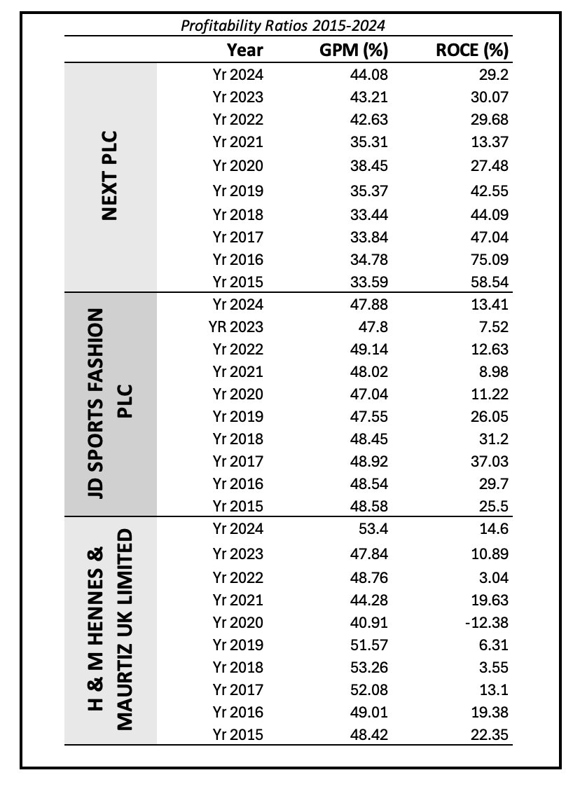

Table1: Profitability Ratios of NEXT, JD Sports and H &M (Source: FAME,2025)

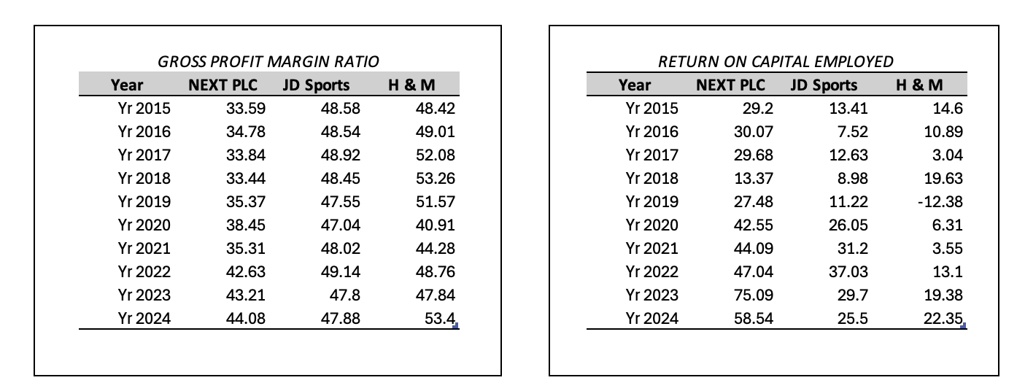
Table 1(a) and Table 1(b) Presenting Gross Profit Ratio and Return on Capital Employed respectively

2. To achieve the results displayed in Section 2 of report following data was used

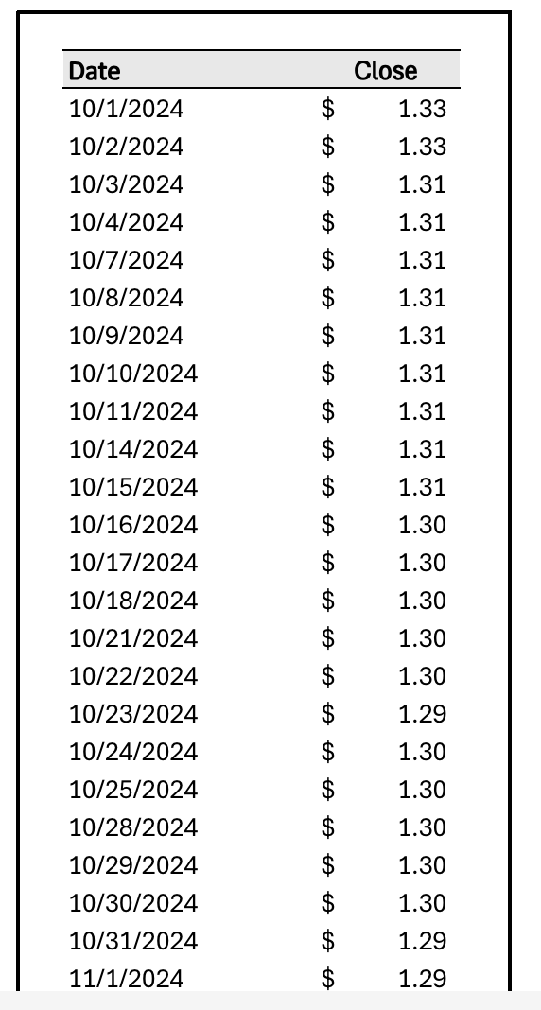

Table 2.1: Currency Pair Selection dropdown and price data retrieved by Stock history function of Excel powered by Refinitiv

7. References

- Brydges, T., Retamal, M., & Hanlon, M. (2020). Will COVID-19 support the transition to a more sustainable fashion industry? Science, Practice and Policy, 16(1), 298–308. https://doi.org/10.1080/15487733.2020.1829848
- British Retail Consortium Report (2025). Retail Industry Statics. Retrieved July 7, 2025, from https://www.brc.org.uk/
- Black, S. (2020). Fashion in a Time of Crisis. Fashion Practice, 12(3), 327–330. https://doi.org/10.1080/17569370.2020.1823624
- Bhardwaj, V. (2010). Fast fashion: Response to changes in the fashion industry. The International Review of Retail, Distribution and Consumer Research, 20(1), 165–173. https://doi.org/10.1080/09593960903498300
- Badhan, I. A., Neeroj, M. H., & Rahman, S. (2024). Currency rate fluctuations and their impact on supply chain risk management: An empirical analysis. International journal of business and management sciences, 4(10), 6-26. . https://doi.org/10.55640/ijbms-04-10-02
- Brydges, T., & Hanlon, M. (2020). Garment worker rights and the fashion industry’s response to COVID-19. Dialogues in Human Geography, 10(2), 195–198. https://doi.org/10.1177/2043820620933851
- Corpay. (2024). Currency risk management: A guide for multinational corporations. https://www.corpay.com/resources/blog/currency-risk-management-a-guide-for-multinational-corporations
- H & M Hennes & Mauritz AB. (2025). Full-year report 2024. H&M Group. https://hmgroup.com/wp-content/uploads/2025/01/H-M-Hennes-Mauritz-AB-Full-year-report-2024.pdf
- H&M Group. (2023). Annual & Sustainability Report 2024. https://hmgroup.com/wp-content/uploads/2025/03/HM-Group-Annual-and-Sustainability-Report-2024.pdf hmgroup.com
- IBM. (n.d.). What is Monte Carlo simulation? IBM Think. Retrieved from https://www.ibm.com/think/topics/monte-carlo-simulation
- IBISWorld. (2025, February). Clothing retailing in the UK – Market research report (Industry Report 3060). IBISWorld.
- JD Sports Fashion PLC. (2024). JD SPORTS FASHION PLC FY25 RESULTS. https://www.jdplc.com/investor-relations/regulatory-news/regulatory-news-details/2025/JD-SPORTS-FASHION-PLC-FY25-RESULTS/default.aspx
- JD Sports Fashion PLC. (2025). JD SPORTS FASHION PLC FY26 RESULTS. https://www.jdplc.com/investor-relations/results-centre/default.aspx
- Koetter, N. J., Krause, D. J., & Liptak, C. S. (2014). Determining relevant financial statement ratios in Department of Defence Service Component General Fund Financial Statements. defence Technical Information Centre. https://hdl.handle.net/10945/42663
- KPMG AG. (2023). Cost of capital study 2023: Unpredictability on the rise! – Interest rates too? What are the drivers, what are the consequences? Retrieved from https://assets.kpmg.com/content/dam/kpmgcampaign/ch/pdf/cost-of-capital-study-2023.pdf
- Lumnitzer, E., Fabianova, J., Janekova, J., Suhanyiova, A., & Suhanyi, L. (2024). The use of simulations in investment decision-making and financing. International Journal of Simulation Modelling, 23(1), 113–124. https://doi.org/10.2507/IJSIMM23-1-677
- Next plc. (2023). Annual report and accounts 2023. Retrieved from https://www.nextplc.co.uk/~/media/Files/N/next-plc-V2/documents/2023/annual-reports-and-account-jan-2023.pdf
- Levi, M. (2022). Exchange rates and the supply chain: Managing currency risk for global firms. Global Finance Journal, 38(2), 88-106. https://doi.org/10.1016/j.gfj. 2022.100512
- Li, X., Yu, H., & Sun, C. (2024). Direct mail or bonded warehouse? Logistics mode selection in cross-border e-commerce under exchange rate risk. Journal of Theoretical and Applied Electronic Commerce Research, 19(3), 2312–2342. https://doi.org/10.3390/jtaer19030112
- McKinsey & Company. (2023). The State of Fashion 2024. Retrieved from https://www.mckinsey.com/industries/retail/our-insights/state-of-fashion-2024?utm
- Mantin, B., Krishnan, H., & Dhar, T. (2014). The strategic role of third-party marketplaces in retailing. Production and Operations Management, 23(10). https://doi.org/10.1111/poms.12203
- Mullner, J. (2017). International project finance: Review and implications for international finance and international business. Management Review Quarterly, 67(2), 97-133. https://doi.org/10.1007/s11301-017-0125-3
- Ostertagová, E., & Ostertag, O. (2013). Methodology and application of one-way ANOVA. American Journal of Mechanical Engineering, 1(7), 256–261. https://doi.org/10.12691/ajme-1-7-21
- Ogah, I., Lambe, I., & Aza, M. S. (2024). Economic and social sustainability reporting and financial performance of listed oil and gas firms in Nigeria. International Journal of Research and Innovation in Social Science, 8(8), 188–206. https://doi.org/10.47772/IJRISS.2024.808017
- Patel, J. (2021). Financial performance in manufacturing: Analysing cost structures and profitability metrics. Journal of Advances in Developmental Research, 12(1), 1–15. Retrieved from https://www.ijaidr.com/papers/2021/1/1315.pdf
- Pellegrino, R. (2024). Mitigating foreign exchange risk exposure with supply chain strategies. Journal of Business Logistics. https://doi.org/10.1111/jbl.12338
- Retail Economics. (2023). Peak Season Report 2023: Building a risk-resistant ecommerce strategy. https://www.retaileconomics.co.uk/retail-insights/thought-leadership-reports/Peak-Trading-Season-Report-2023
- Rosario, S. (2024). The Impact of Return on Capital Employed (ROCE) on Market Valuation: An Empirical Analysis. RVIM Journal, 2024. https://doi.org/10.70599/rvim/2024/353
- Taylor, M. P., Wang, Z., & Xu, Q. (2021). The real effects of exchange rate risk on corporate investment: International evidence. Journal of International Money and Finance, 117, 102432. https://doi.org/10.1016/j.jimonfin.2021.102432
- Worker Rights Consortium. (2020). Covid-19 tracker: Which brands are acting responsibly toward suppliers and workers? Retrieved August 31, 2020, from https://www.workersrights.org/issues/covid-19/tracker/#AboutTracker

